NEW MEXICO PRESCRIPTION DRUG CLAIM SYSTEM

REPORT SPECIFICATION
M1600 Top Prescribed Drugs Ranked by Amount Paid

Report ID: M1600
Title: Top Prescribed Drugs Ranked by Amount Paid
Frequency: Monthly
Source: OS PLUS Oracle DSS Warehouse; report generated via Business Objects
Description: This report provides a ranking of the Top Prescribed Drugs by “Amount Paid”. It includes line item information for the following metrics: Rank, GCN, GCN Name, Therapeutic Class Code, Therapeutic Class Description, # of Claims, Amount Paid, Avg Amount Paid/Claim, and Avg Quantity/Claim. The summary at the bottom of the report shows Subtotals, Percents and Averages of the Top Prescribed Drugs compared to All Prescribed Drugs for each metric. The summary also shows Totals and Averages for All Prescribed Drugs for each metric. Top Drug reports help to prioritize utilization review programs and to predict the effect of reimbursement system or benefit delivery design changes.
Metrics: Rank - Ranking of Top Prescribed Drugs Ranked by Amount Paid
GCN - Generic Code Number
GCN Name - Generic Drug Name and Strength and Form
Therapeutic Class Code - Therapeutic Class Code groups drugs according to their most common intended use by FDB
Therapeutic Class Description - Description of each Therapeutic Class Code
# of Claims - Unique Count of TCNs
Amount Paid - Amount Paid by the Client per Generic Drug Name
Avg Amount Paid/Claim - Sum of Amount Paid per Generic Drug Name divided by the Sum of the # of Claims
Avg Quantity/Claim - Sum of Quantity for each Claim divided by the Sum of the # of Claims
Summaries:
# of Claims:
Totals - Count of Claims for Top Prescribed Drug Names
Percents - Sum of the # of Claims for Top Prescribed Drug Names divided by the Sum of the # of Claims for All Prescribed
Drug Names
Averages - Sum of the # of Claims for Top Prescribed Drug Names divided by the # of Top Prescribed Drug Names
Totals For All - Sum of the # of Claims for All Prescribed Drug Names
Averages for All - Sum of the # of Claims for All Prescribed Drug Names divided by the # of All Prescribed Drug Names
Amount Paid:
Totals - Sum of Amount Paid for Top Prescribed Drug Names
Percents - Sum of Amount Paid for Top Prescribed Drug Names divided by Sum of Amount Paid for All Prescribed Drug
Names
Averages - Sum of Amount Paid for Top Prescribed Drug Names divided by the # of Top Prescribed Drug Names
Totals For All - Sum of Amount Paid for All Prescribed Drug Names
Averages for All - Sum of Amount Paid for All Prescribed Drug Names divided by the # of All Prescribed Drug Names
Avg Amount Paid/Claim:
Averages - Sum of Amount Paid for Top Prescribed Drug Names divided by # of Claims for Top Prescribed Drug Names
Averages for All - Sum of Amount Paid for Top Prescribed Drug Names divided by # of Claims for All Prescribed Drug
Names
Quantity/Claim:
Averages - Sum of Quantity per Claim for Top Prescribed Drug Names divided by the # of Claims for Top Prescribed Drug
Names
Averages for All - Sum of Quantity per Claim for All Prescribed Drug Names divided by the # of Claims for All Prescribed Drug Names
Sort Sequence(s): Top Prescribed Drugs Ranked by Amount Paid
Control Breaks: Rank Top 100
Filters: N/A
Notes: N/A

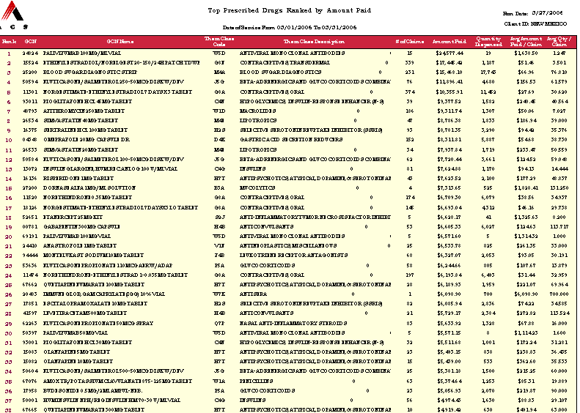
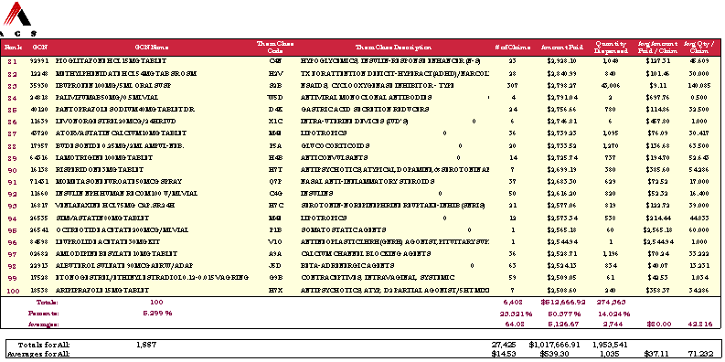
NEW MEXICO PRESCRIPTION DRUG CLAIM SYSTEM

REPORT SPECIFICATION
M1610 Top Prescribed Drugs Ranked by Number of Prescriptions

Report ID: M1610
Title: Top Prescribed Drugs Ranked by Number of Prescriptions
Frequency: Monthly
Source: OS PLUS Oracle DSS Warehouse; report generated via Business Objects
Description: This report provides a ranking of the Top Prescribed Drugs by “Number of Prescriptions”. It includes line item information for the following metrics: Rank, GCN, GCN Name, Therapeutic Class Code, Therapeutic Class Description, # of Claims, Amount Paid, Avg Amount Paid/Claim, and Avg Quantity/Claim. The summary at the bottom of the report shows Subtotals, Percents and Averages of the Top Prescribed Drugs compared to All Prescribed Drugs for each metric. The summary also shows Totals and Averages for All Prescribed Drugs for each metric. Top Drug reports help to prioritize utilization review programs and to predict the effect of reimbursement system or benefit delivery design changes.
Metrics: Rank - Ranking of Top Prescribed Drugs by Number of Prescriptions
GCN - Generic Code Number
GCN Name - Generic Drug Name and Strength and Form
Therapeutic Class Code - Therapeutic Class Code groups drugs according to their most common intended use by FDB
Therapeutic Class Description - Description of each Therapeutic Class Code
# of Claims - Unique Count of TCNs
Amount Paid - Amount Paid by the Client per Generic Drug Name
Avg Amount Paid/Claim - Sum of Amount Paid per Generic Drug Name divided by the Sum of the # of Claims
Avg Quantity/Claim - Sum of Quantity for each Claim divided by the Sum of the # of Claims
Summaries:
# of Claims:
Totals - Count of Claims for Top Prescribed Drug Names
Percents - Sum of the # of Claims for Top Prescribed Drug Names divided by the Sum of the # of Claims for All Prescribed
Drug Names
Averages - Sum of the # of Claims for Top Prescribed Drug Names divided by the # of Top Prescribed Drug Names
Totals For All - Sum of the # of Claims for All Prescribed Drug Names
Averages for All - Sum of the # of Claims for All Prescribed Drug Names divided by the # of All Prescribed Drug Names
Amount Paid:
Totals - Sum of Amount Paid for Top Prescribed Drug Names
Percents - Sum of Amount Paid for Top Prescribed Drug Names divided by Sum of Amount Paid for All Prescribed Drug
Names
Averages - Sum of Amount Paid for Top Prescribed Drug Names divided by the # of Top Prescribed Drug Names
Totals For All - Sum of Amount Paid for All Prescribed Drug Names
Averages for All - Sum of Amount Paid for All Prescribed Drug Names divided by the # of All Prescribed Drug Names
Avg Amount Paid/Claim:
Averages - Sum of Amount Paid for Top Prescribed Drug Names divided by # of Claims for Top Prescribed Drug Names
Averages for All - Sum of Amount Paid for Top Prescribed Drug Names divided by # of Claims for All Prescribed Drug
Names
Quantity/Claim:
Averages - Sum of Quantity per Claim for Top Prescribed Drug Names divided by the # of Claims for Top Prescribed Drug
Names
Averages for All - Sum of Quantity per Claim for All Prescribed Drug Names divided by the # of Claims for All Prescribed Drug Names
Sort Sequence(s): Top Prescribed Drugs Ranked by Number of Prescriptions
Control Breaks: Rank Top 100
Filters: N/A
Notes: N/A

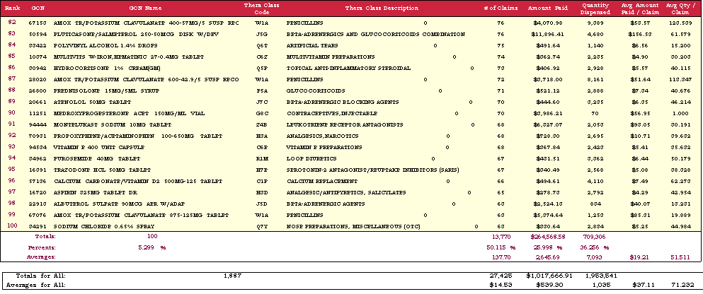

NEW MEXICO PRESCRIPTION DRUG CLAIM SYSTEM

REPORT SPECIFICATION
M1615 Prescribed Drugs for State Fiscal Year to Date

Report ID: M1615
Title: Prescribed Drugs for State Fiscal Year to Date
Frequency: Monthly
Source: OS PLUS Oracle DSS Warehouse; report generated via Business Objects
Description: This report provides information on all Prescribed Drugs for state fiscal year to date. It includes line item information for the following metrics: Drug Name, GCN, Generic Code Name, Therapeutic Class Code, Therapeutic Class Description, Brand or Generic, # of Claims, Amount Paid, Avg Amount Paid/Claim, Avg Quantity/Claim. The summary at the bottom of the report shows Totals and Averages of All Prescribed Drugs for each metric.
Metrics: Drug Name - Drug Name & Strength
GCN - Generic Code Number
GCN Name - Generic Drug Name and Strength
Therapeutic Class Code - Specific Therapeutic Class Code groups drugs according to their most common intended use
Therapeutic Class Description - Description of each Therapeutic Class Code
# of Claims - Unique Count of TCNs
Brand or Generic - Generic Defined as GPI = 1 Else Brand
Amount Paid - Amount Paid for the Claim
Avg Amount Paid/Claim - Sum of the Amount Paid divided by the # of Claims
Avg Quantity/Claim - Sum of Quantity per Claim divided by the # of Claims
Summaries:
Generic Drug Name:
Totals For All - Unique Count of Generic Drug Names
# of Claims:
Totals For All - Sum of the # of Claims for All Generic Drug Names
Averages For All - Sum of the # of Claims All Generic Drug Names divided by the # of Generic Drug Names
Amount Paid:
Totals For All - Sum of Amount Paid for All Generic Drug Names
Averages For All - Sum of Amount Paid All Generic Drug Names divided by the # of Generic Drug Names
Quantity:
Totals For All - Sum of the Quantity per Claim for All Generic Drug Names
Averages For All - Sum of the Quantity per Claim for All Generic Drug Names divided by the # of Generic Drug Names
Avg Amount Paid/Claim:
Averages for All - Sum of Amount Paid All Generic Drug Names divided by Sum of the # of Claims for All Generic Drug
Names
Avg Quantity/Claim:
Averages for All - Sum of Quantity per Claim All Generic Drug Names divided by Sum of the # of Claims for All Generic Drug Names
Sort Sequence(s): N/A
Control Breaks: N/A
Filters: N/A
Notes: All Generic Drug Names with Paid Claims in Current State Fiscal Year are Reported

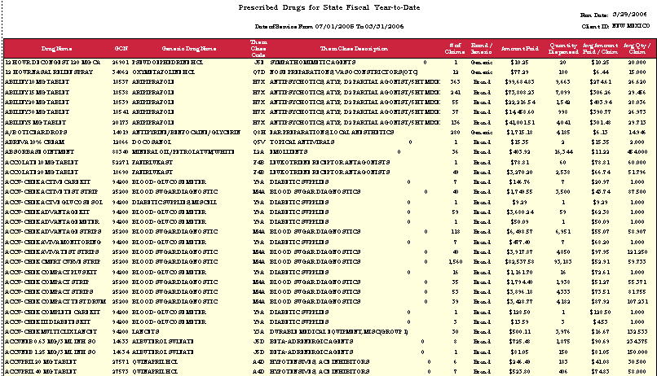
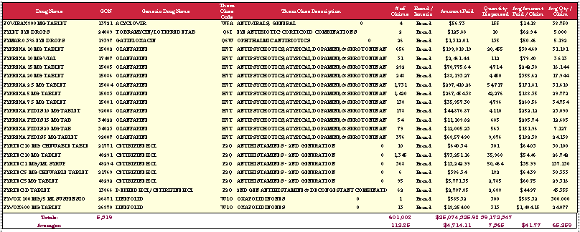
NEW MEXICO PRESCRIPTION DRUG CLAIM SYSTEM

REPORT SPECIFICATION
M1620 Top Prescribed Brand Drugs Ranked by Amount Paid

Report ID: M1620
Title: Top Prescribed Brand Drugs Ranked by Amount Paid
Frequency: Monthly
Source: OS PLUS Oracle DSS Warehouse; report generated via Business Objects
Description: This report provides a ranking of the Top Prescribed Brand Drugs by “Amount Paid”. It includes line item information for the following metrics: Rank, Drug Name, GCN, Generic Code Name, Therapeutic Class Code, Therapeutic Class Description, # of Claims, Amount Paid, Avg Amount Paid/Claim, Avg Quantity/Claim. The summary at the bottom of the report shows Subtotals, Percents and Averages of the Top Prescribed Brand Drugs compared to All Prescribed Brand Drugs for each metric. The summary also shows Totals and Averages for All Prescribed Brand Drugs for each metric. Top product reports help to prioritize utilization review programs and to predict the effect of reimbursement system or benefit delivery design changes.
Metrics: Rank - Ranking of Top Prescribed Brand Drugs Ranked by Amount Paid
Drug Name - Drug Name & Strength
GCN - Generic Code Number
GCN Name - Generic Drug Name and Strength
Therapeutic Class Code - Specific Therapeutic Class Code groups drugs according to their most common intended use
Therapeutic Class Description - Description of each Therapeutic Class Code
# of Claims - Unique Count of TCNs
Amount Paid - Amount Paid for the Claim
Avg Amount Paid/Claim - Sum of the Amount Paid divided by the # of Claims
Avg Quantity/Claim - Sum of Quantity per Claim divided by the # of Claims
Summaries:
Brand Drug Name:
Totals For All - Unique Count of Brand Drug Names
# of Claims:
Totals - Count of Claims for Top Prescribed Brand Drug Names
Percents - Sum of the # of Claims for Top Prescribed Brand Drug Names divided by the Sum of the # of Claims for
All Prescribed Brand Drug Names
Averages - Sum of the # of Claims for Top Prescribed Brand Drug Names divided by the # of All Prescribed Brand Drug
Names
Totals For All - Sum of the # of Claims for All Prescribed Brand Drugs
Averages for All - Sum of the # of Claims for All Prescribed Brand Drugs Names divided by the # of All Prescribed Brand
Drug Names
Amount Paid:
Totals - Sum of Amount Paid for Top Prescribed Brand Drug Names
Percents - Sum of Amount Paid for Top Prescribed Brand Drug Names divided by Sum of Amount Paid for All Prescribed
Brand Drug Names
Averages - Sum of Amount Paid for Top Prescribed Brand Drug Names divided by the # of Top Prescribed Brand Drug
Names
Totals For All - Sum of Amount Paid for All Prescribed Brand Drug Names
Averages for All - Sum of Amount Paid for All Prescribed Brand Drug Names divided by the # of All Prescribed Brand Drug
Names
Avg Amount Paid/Claim:
Averages - Sum of Amount Paid for Top Prescribed Brand Drug Names divided by # of Claims for Top Prescribed Brand
Drug Names
Averages for All - Sum of Amount Paid for Top Prescribed Brand Drug Names divided by # of Claims for All Prescribed
Brand Drug Names
Avg Quantity/Claim:
Averages - Sum of Quantity per Claim for Top Prescribed Brand Drug Names divided by the # of Claims for Top Prescribed Brand Drug Names
Averages for All - Sum of Quantity per Claim for All Prescribed Brand Drug Names divided by the # of Claims for All Prescribed Brand Drug Names
Sort Sequence(s): Top Prescribed Brand Drugs Ranked by Amount Paid
Control Breaks: Rank Top 100
Filters: Brand Drug only, where GPI <> 1
Notes: N/A

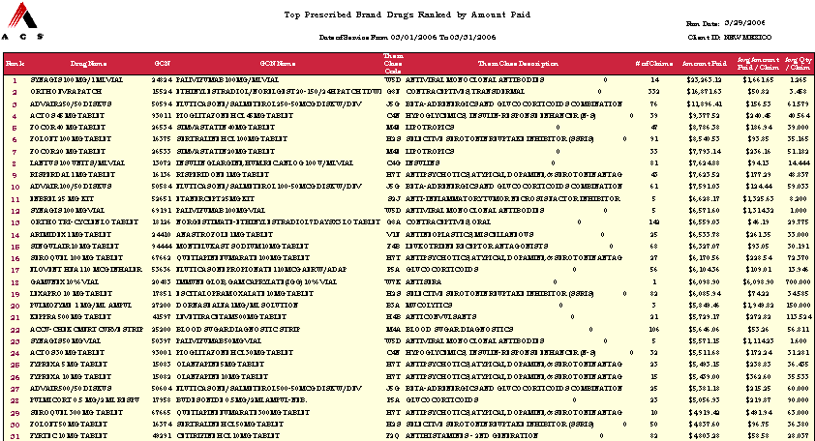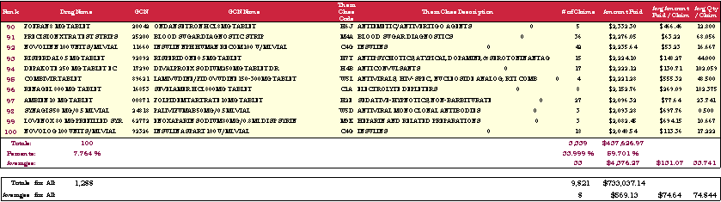
NEW MEXICO PRESCRIPTION DRUG CLAIM SYSTEM

REPORT SPECIFICATION
M1630 Top Prescribed Brand Drugs Ranked by Number of Prescriptions

Report ID: M1630
Title: Top Prescribed Brand Drugs Ranked by Number of Prescriptions
Frequency: Monthly
Source: OS PLUS Oracle DSS Warehouse; report generated via Business Objects
Description: This report provides a ranking of the Top Prescribed Brand Drugs by “Number of Prescriptions”. It includes line item information for the following metrics: Rank, Drug Name, GCN, Generic Code Name, Therapeutic Class Code, Therapeutic Class Description, # of Claims, Amount Paid, Avg Amount Paid/Claim, Avg Quantity/Claim. The summary at the bottom of the report shows Subtotals, Percents and Averages of the Top Prescribed Brand Drugs compared to All Prescribed Brand Drugs for each metric. The summary also shows Totals and Averages for All Prescribed Brand Drugs for each metric. Top product reports help to prioritize utilization review programs and to predict the effect of reimbursement system or benefit delivery design changes.
Metrics: Rank - Ranking of Top Prescribed Brand Drugs Ranked by Number of Prescriptions
Drug Name - Drug Name & Strength
GCN - Generic Code Number
GCN Name - Generic Drug Name and Strength
Therapeutic Class Code - Specific Therapeutic Class Code groups drugs according to their most common intended use
Therapeutic Class Description - Description of each Therapeutic Class Code
# of Claims - Unique Count of TCNs
Amount Paid - Amount Paid for the Claim
Avg Amount Paid/Claim - Sum of the Amount Paid divided by the # of Claims
Avg Quantity/Claim - Sum of Quantity per Claim divided by the # of Claims
Summaries:
Brand Drug Name:
Totals For All - Unique Count of Brand Drug Names
# of Claims:
Totals - Count of Claims for Top Prescribed Brand Drug Names
Percents - Sum of the # of Claims for Top Prescribed Brand Drug Names divided by the Sum of the # of Claims for
All Prescribed Brand Drug Names
Averages - Sum of the # of Claims for Top Prescribed Brand Drug Names divided by the # of All Prescribed Brand Drug
Names
Totals For All - Sum of the # of Claims for All Prescribed Brand Drugs
Averages for All - Sum of the # of Claims for All Prescribed Brand Drugs Names divided by the # of All Prescribed Brand
Drug Names
Amount Paid:
Totals - Sum of Amount Paid for Top Prescribed Brand Drug Names
Percents - Sum of Amount Paid for Top Prescribed Brand Drug Names divided by Sum of Amount Paid for All Prescribed
Brand Drug Names
Averages - Sum of Amount Paid for Top Prescribed Brand Drug Names divided by the # of Top Prescribed Brand Drug
Names
Totals For All - Sum of Amount Paid for All Prescribed Brand Drug Names
Averages for All - Sum of Amount Paid for All Prescribed Brand Drug Names divided by the # of All Prescribed Brand Drug
Names
Avg Amount Paid/Claim:
Averages - Sum of Amount Paid for Top Prescribed Brand Drug Names divided by # of Claims for Top Prescribed Brand
Drug Names
Averages for All - Sum of Amount Paid for Top Prescribed Brand Drug Names divided by # of Claims for All Prescribed
Brand Drug Names
Avg Quantity/Claim:
Averages - Sum of Quantity per Claim for Top Prescribed Brand Drug Names divided by the # of Claims for Top Prescribed Brand Drug Names
Averages for All - Sum of Quantity per Claim for All Prescribed Brand Drug Names divided by the # of Claims for All Prescribed Brand Drug Names
Sort Sequence(s): Top Prescribed Brand Drugs Ranked by Number of Prescriptions
Control Breaks: Rank Top 100
Filters: Brand Drug only, where GPI <> 1
Notes: N/A
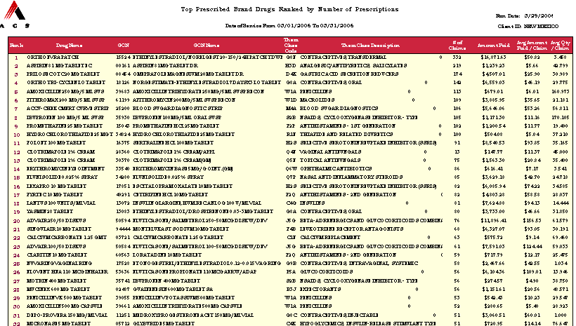
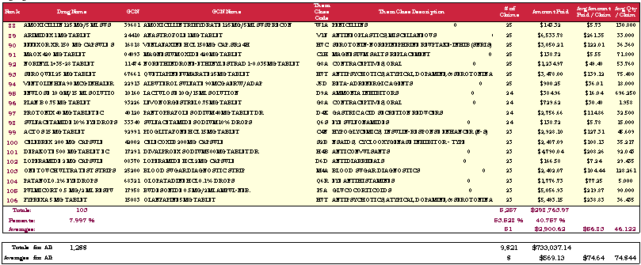
NEW MEXICO PRESCRIPTION DRUG CLAIM SYSTEM

REPORT SPECIFICATION
M1640 Top Prescribed Generic Drugs Ranked by Amount Paid

Report ID: M1640
Title: Top Prescribed Generic Drugs Ranked by Amount Paid
Frequency: Monthly
Source: OS PLUS Oracle DSS Warehouse; report generated via Business Objects
Description: This report provides a ranking of the Top Prescribed Generic Drugs by “Amount Paid”. It includes line item information for the following metrics: Rank, GCN, Generic Code Name, Therapeutic Class Code, Therapeutic Class Description, # of Claims, Amount Paid, Avg Amount Paid/Claim, Avg Quantity/Claim. The summary at the bottom of the report shows Subtotals, Percents and Averages of the Top Prescribed Generic Drugs compared to All Prescribed Generic Drugs for each metric. The summary also shows Totals and Averages for All Prescribed Generic Drugs for each metric. Top product reports help to prioritize utilization review programs and to predict the effect of reimbursement system or benefit delivery design changes.
Metrics: Rank - Ranking of Top Prescribed Generic Drugs Ranked by Amount Paid
Drug Name - Drug Name & Strength
GCN - Generic Code Number
GCN Name - Generic Drug Name and Strength
Therapeutic Class Code - Specific Therapeutic Class Code groups drugs according to their most common intended use
Therapeutic Class Description - Description of each Therapeutic Class Code
# of Claims - Unique Count of TCNs
Amount Paid - Amount Paid for the Claim
Avg Amount Paid/Claim - Sum of the Amount Paid divided by the # of Claims
Avg Quantity/Claim - Sum of Quantity per Claim divided by the # of Claims
Summaries:
Generic Drug Name:
Totals For All - Unique Count of Generic Drug Names
# of Claims:
Totals - Count of Claims for Top Prescribed Generic Drug Names
Percents - Sum of the # of Claims for Top Prescribed Generic Drug Names divided by the Sum of the # of Claims for
All Prescribed Generic Drug Names
Averages - Sum of the # of Claims for Top Prescribed Generic Drug Names divided by the # of All Prescribed Generic Drug
Names
Totals For All - Sum of the # of Claims for All Prescribed Generic Drugs
Averages for All - Sum of the # of Claims for All Prescribed Generic Drugs Names divided by the # of All Prescribed
Generic Drug Names
Amount Paid:
Totals - Sum of Amount Paid for Top Prescribed Generic Drug Names
Percents - Sum of Amount Paid for Top Prescribed Generic Drug Names divided by Sum of Amount Paid for All Prescribed
Generic Drug Names
Averages - Sum of Amount Paid for Top Prescribed Generic Drug Names divided by the # of Top Prescribed Generic Drug
Names
Totals For All - Sum of Amount Paid for All Prescribed Generic Drug Names
Averages for All - Sum of Amount Paid for All Prescribed Generic Drug Names divided by the # of All Prescribed Generic
Drug Names
Avg Amount Paid/Claim:
Averages - Sum of Amount Paid for Top Prescribed Generic Drug Names divided by # of Claims for Top Prescribed Generic
Drug Names
Averages for All - Sum of Amount Paid for Top Prescribed Generic Drug Names divided by # of Claims for All Prescribed
Generic Drug Names
Avg Quantity/Claim:
Averages - Sum of Quantity per Claim for Top Prescribed Generic Drug Names divided by the # of Claims for Top Prescribed Generic Drug Names
Averages for All - Sum of Quantity per Claim for All Prescribed Generic Drug Names divided by the # of Claims for All Prescribed Generic Drug Names
Sort Sequence(s): Top Prescribed Generic Drugs Ranked by Amount Paid
Control Breaks: Rank Top 100
Filters: Brand Drug only, where GPI = 1
Notes: N/A

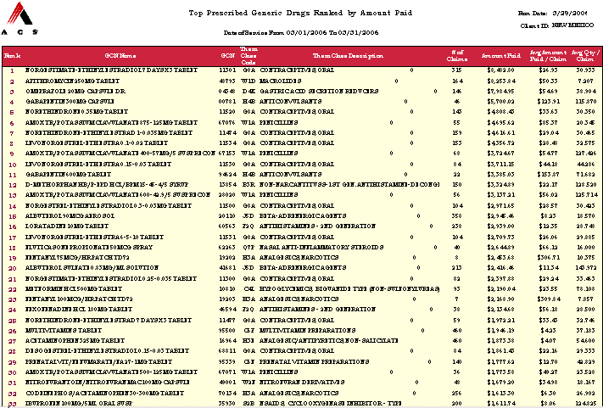
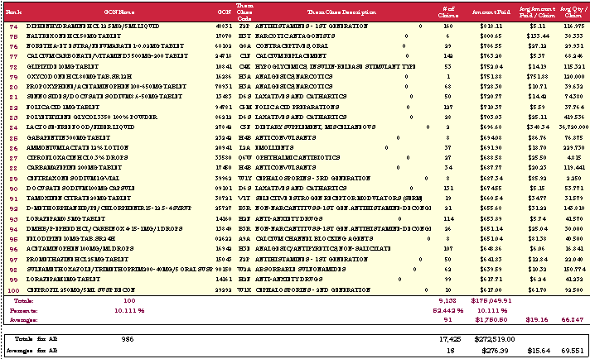
NEW MEXICO PRESCRIPTION DRUG CLAIM SYSTEM

REPORT SPECIFICATION
M1650 Top Prescribed Generic Drugs Ranked by Number of Prescriptions

Report ID: M1650
Title: Top Prescribed Generic Drugs Ranked by Number of Prescriptions
Frequency: Monthly
Source: OS PLUS Oracle DSS Warehouse; report generated via Business Objects
Description: This report provides a ranking of the Top Prescribed Generic Drugs by “Number of Prescriptions”. It includes line item information for the following metrics: Rank, GCN, Generic Code Name, Therapeutic Class Code, Therapeutic Class Description, # of Claims, Amount Paid, Avg Amount Paid/Claim, Avg Quantity/Claim. The summary at the bottom of the report shows Subtotals, Percents and Averages of the Top Prescribed Generic Drugs compared to All Prescribed Generic Drugs for each metric. The summary also shows Totals and Averages for All Prescribed Generic Drugs for each metric. Top product reports help to prioritize utilization review programs and to predict the effect of reimbursement system or benefit delivery design changes.
Metrics: Rank - Ranking of Top Prescribed Generic Drugs Ranked by Number of Prescriptions
Drug Name - Drug Name & Strength
GCN - Generic Code Number
GCN Name - Generic Drug Name and Strength
Therapeutic Class Code - Specific Therapeutic Class Code groups drugs according to their most common intended use
Therapeutic Class Description - Description of each Therapeutic Class Code
# of Claims - Unique Count of TCNs
Amount Paid - Amount Paid for the Claim
Avg Amount Paid/Claim - Sum of the Amount Paid divided by the # of Claims
Avg Quantity/Claim - Sum of Quantity per Claim divided by the # of Claims
Summaries:
Generic Drug Name:
Totals For All - Unique Count of Generic Drug Names
# of Claims:
Totals - Count of Claims for Top Prescribed Generic Drug Names
Percents - Sum of the # of Claims for Top Prescribed Generic Drug Names divided by the Sum of the # of Claims for
All Prescribed Generic Drug Names
Averages - Sum of the # of Claims for Top Prescribed Generic Drug Names divided by the # of All Prescribed Generic Drug
Names
Totals For All - Sum of the # of Claims for All Prescribed Generic Drugs
Averages for All - Sum of the # of Claims for All Prescribed Generic Drugs Names divided by the # of All Prescribed
Generic Drug Names
Amount Paid:
Totals - Sum of Amount Paid for Top Prescribed Generic Drug Names
Percents - Sum of Amount Paid for Top Prescribed Generic Drug Names divided by Sum of Amount Paid for All Prescribed
Generic Drug Names
Averages - Sum of Amount Paid for Top Prescribed Generic Drug Names divided by the # of Top Prescribed Generic Drug
Names
Totals For All - Sum of Amount Paid for All Prescribed Generic Drug Names
Averages for All - Sum of Amount Paid for All Prescribed Generic Drug Names divided by the # of All Prescribed Generic
Drug Names
Avg Amount Paid/Claim:
Averages - Sum of Amount Paid for Top Prescribed Generic Drug Names divided by # of Claims for Top Prescribed Generic
Drug Names
Averages for All - Sum of Amount Paid for Top Prescribed Generic Drug Names divided by # of Claims for All Prescribed
Generic Drug Names
Avg Quantity/Claim:
Averages - Sum of Quantity per Claim for Top Prescribed Generic Drug Names divided by the # of Claims for Top Prescribed Generic Drug Names
Averages for All - Sum of Quantity per Claim for All Prescribed Generic Drug Names divided by the # of Claims for All Prescribed Generic Drug Names
Sort Sequence(s): Top Prescribed Generic Drugs Ranked by Number of Prescriptions
Control Breaks: Rank Top 100
Filters: Generic Drugs only, where GPI = 1
Notes: N/A
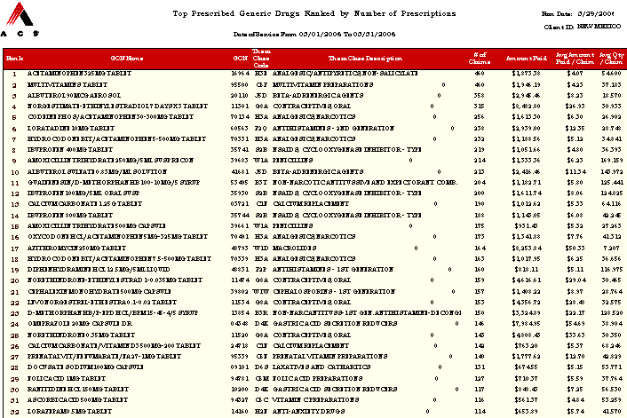
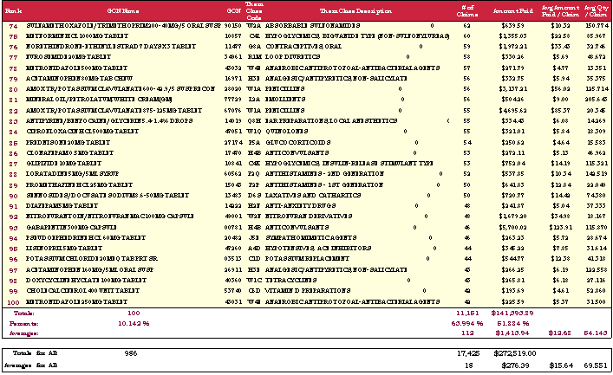
NEW MEXICO PRESCRIPTION DRUG CLAIM SYSTEM

REPORT SPECIFICATION
M1660 Top Prescribed Injectables Ranked by Amount Paid

Report ID: M1660
Title: Top Prescribed Injectables Ranked by Amount Paid
Frequency: Monthly
Source: OS PLUS Oracle DSS Warehouse; report generated via Business Objects
Description: This report provides a ranking of the Top Prescribed Injectable Drugs by “Amount Paid”. It includes line item information for the following metrics: Rank, NDC, Drug Name, GCN, Generic Code Name, Therapeutic Class Code, Therapeutic Class Description, # of Claims, Amount Paid, Avg Amount Paid/Claim, Avg Quantity/Claim. The summary at the bottom of the report shows Subtotals, Percents and Averages of the Top Prescribed Injectable Drugs compared to All Prescribed Injectable Drugs for each metric. The summary also shows Totals and Averages for All Prescribed Injectable Drugs for each metric. Top product reports help to prioritize utilization review programs and to predict the effect of reimbursement system or benefit delivery design changes.
Metrics: Rank - Ranking of Top Prescribed Injectables Ranked by Amount Paid
NDC - National Drug Code
Drug Name - Drug Name & Strength
GCN - Generic Code Number
GCN Name - Generic Drug Name and Strength
Therapeutic Class Code - Specific Therapeutic Class Code groups drugs according to their most common intended use
Therapeutic Class Description - Description of each Therapeutic Class Code
# of Claims - Unique Count of TCNs
Amount Paid - Amount Paid for the Claim
Avg Amount Paid/Claim - Sum of the Amount Paid divided by the # of Claims
Avg Quantity/Claim - Sum of Quantity per Claim divided by the # of Claims
Summaries:
Drug Name:
Totals For All - Unique Count of Drug Names
# of Claims:
Totals - Count of Claims for Top Prescribed Injectable Drug Names
Percents - Sum of the # of Claims for Top Prescribed Injectable Drug Names divided by the Sum of the # of Claims for All
Prescribed Injectable Drug Names
Averages - Sum of the # of Claims for Top Prescribed Injectable Drug Names divided by the # of Top Prescribed Injectable
Drug Names
Totals For All - Sum of the # of Claims for All Prescribed Injectable Drug Names
Averages for All - Sum of the # of Claims for All Prescribed Injectable Drug Names divided by the # of All Prescribed
Injectable Drug Names
Amount Paid:
Totals - Sum of Amount Paid for Top Prescribed Injectable Drug Names
Percents - Sum of Amount Paid for Top Prescribed Injectable Drug Names divided by Sum of Amount Paid for All
Prescribed Injectable Drug Names
Averages - Sum of Amount Paid for Top Prescribed Injectable Drug Names divided by the # of Top Prescribed Injectable
Drug Names
Totals For All - Sum of Amount Paid for All Prescribed Injectable Drug Names
Averages for All - Sum of Amount Paid for All Prescribed Injectable Drug Names divided by the # of All Prescribed
Injectable Drug Names
Avg Amount Paid/Claim:
Averages - Sum of Amount Paid for Top Prescribed Injectable Drug Names divided by # of Claims for Top Prescribed
Injectable Drug Names
Averages for All - Sum of Amount Paid for Top Prescribed Injectable Drug Names divided by # of Claims for All Prescribed
Injectable Drug Names
Quantity/Claim:
Averages - Sum of Quantity per Claim for Top Prescribed Injectable Drug Names divided by the # of Claims for Top
Prescribed Injectable Drug Names
Averages for All - Sum of Quantity per Claim for All Prescribed Injectable Drug Names divided by the # of Claims for All Prescribed Injectable Drug Names
Sort Sequence(s): Top Prescribed Injectables Ranked by Amount Paid
Control Breaks: Ranked Top 100
Filters: N/A
Notes: Report may not contain 100 Injectable Drugs due to State Utilization Patterns.
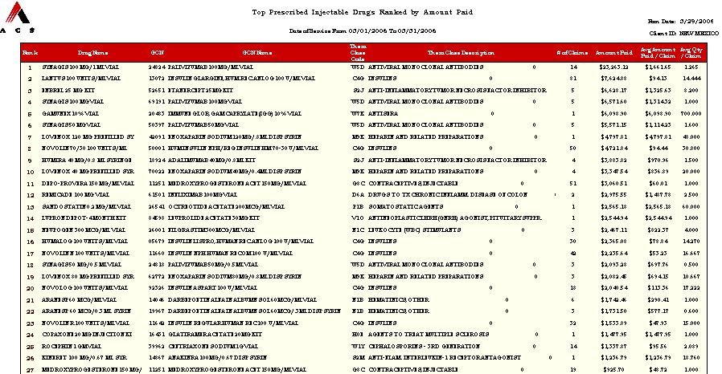
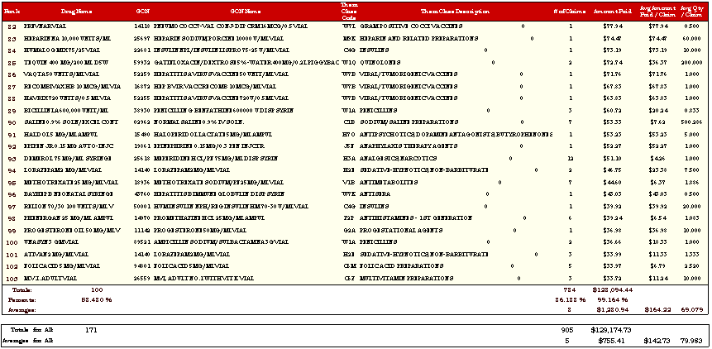
NEW MEXICO PRESCRIPTION DRUG CLAIM SYSTEM

REPORT SPECIFICATION
M1680 Top Prescribed OTC Drugs Ranked by Amount Paid

Report ID: M1680
Title: Top Prescribed OTC Drugs Ranked by Amount Paid
Frequency: Monthly
Source: OS PLUS Oracle DSS Warehouse; report generated via Business Objects
Description: This report provides a ranking of the Top Prescribed OTC Drugs by “Amount Paid”. It includes line item information for the following metrics: Rank, NDC, Drug Name, GCN, Generic Code Name, Therapeutic Class Code, Therapeutic Class Description, # of Claims, Amount Paid, Avg Amount Paid/Claim, Avg Quantity/Claim. The summary at the bottom of the report shows Subtotals, Percents and Averages of the Top Prescribed OTC Drugs compared to All Prescribed OTC Drugs for each metric. The summary also shows Totals and Averages for All Prescribed OTC Drugs for each metric. Top product reports help to prioritize utilization review programs and to predict the effect of reimbursement system or benefit delivery design changes.
Metrics: Rank - Ranking of Top Prescribed OTC Drugs Ranked by Amount Paid
Drug Name - Drug Name & Strength
GCN - Generic Code Number
GCN Name - Generic Drug Name and Strength
Therapeutic Class Code - Specific Therapeutic Class Code groups drugs according to their most common intended use
Therapeutic Class Description - Description of each Therapeutic Class Code
# of Claims - Unique Count of TCNs
Amount Paid - Amount Paid for the Claim
Avg Amount Paid/Claim - Sum of the Amount Paid divided by the # of Claims
Avg Quantity/Claim - Sum of Quantity per Claim divided by the # of Claims
Summaries:
Drug Name:
Totals For All - Unique Count of Drug Names
# of Claims:
Totals - Count of Claims for Top Prescribed OTC Drug Names
Percents - Sum of the # of Claims for Top Prescribed OTC Drug Names divided by the Sum of the # of Claims for All
Prescribed OTC Drug Names
Averages - Sum of the # of Claims for Top Prescribed OTC Drug Names divided by the # of Top Prescribed OTC Drug
Names
Totals For All - Sum of the # of Claims for All Prescribed OTC Drug Names
Averages for All - Sum of the # of Claims for All Prescribed OTC Drug Names divided by the # of All Prescribed OTC
Drug Names
Amount Paid:
Totals - Sum of Amount Paid for Top Prescribed OTC Drug Names
Percents - Sum of Amount Paid for Top Prescribed OTC Drug Names divided by Sum of Amount Paid for All Prescribed
OTC Drug Names
Averages - Sum of Amount Paid for Top Prescribed OTC Drug Names divided by the # of Top Prescribed OTC Drug Names
Totals For All - Sum of Amount Paid for All Prescribed OTC Drug Names
Averages for All - Sum of Amount Paid for All Prescribed OTC Drug Names divided by the # of All Prescribed OTC Drug
Names
Avg Amount Paid/Claim:
Averages - Sum of Amount Paid for Top Prescribed OTC Drug Names divided by # of Claims for Top Prescribed OTC Drug
Names
Averages for All - Sum of Amount Paid for Top Prescribed OTC Drug Names divided by # of Claims for All Prescribed
OTC Drug Names
Quantity/Claim:
Averages - Sum of Quantity per Claim for Top Prescribed OTC Drug Names divided by the # of Claims for Top Prescribed
OTC Drug Names
Averages for All - Sum of Quantity per Claim for All Prescribed OTC Drug Names divided by the # of Claims for All Prescribed OTC Drug Names
Sort Sequence(s): Top Prescribed OTC Drugs Ranked by Amount Paid
Control Breaks: Rank Top 100
Filters: N/A
Notes: N/A
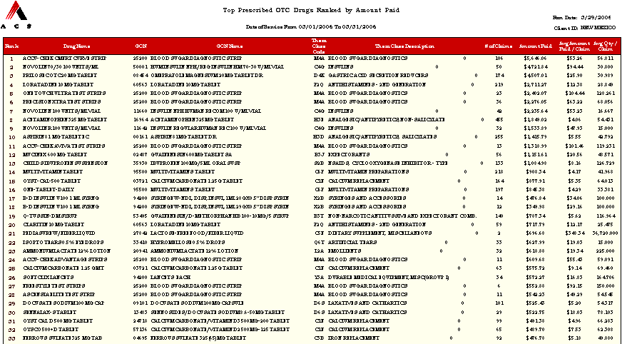
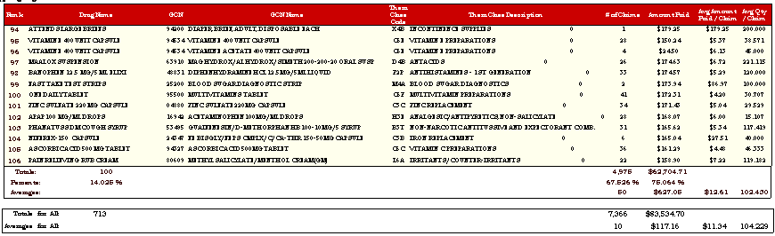
NEW MEXICO PRESCRIPTION DRUG CLAIM SYSTEM

REPORT SPECIFICATION
M1800 Top Therapeutic Classes Ranked by Amount Paid

Report ID: M1800
Title: Top Therapeutic Classes Ranked by Amount Paid
Frequency: Monthly
Source: OS PLUS Oracle DSS Warehouse; report generated via Business Objects
Description: This report provides a ranking of the Top Therapeutic Classes by “Amount Paid”. It includes line item information for the following metrics: Rank, Therapeutic Class Code, Therapeutic Class Description, # of Claims, Amount Paid, % of Top Therapeutic Classes, % of Amount Paid, Avg Amount Paid/Claim. The summary at the bottom of the report shows Subtotals, Percents and Averages of the Top Therapeutic Classes compared to All Therapeutic Classes for each metric. The summary also shows Totals and Averages for All Therapeutic Classes for each metric. Top Therapeutic Class reports help to prioritize utilization review programs and to predict the effect of reimbursement system or benefit delivery design changes.
Metrics: Rank - Ranking of Top Therapeutic Classes by Amount Paid
Therapeutic Class Code - Therapeutic Class Code groups drugs according to their most common intended use
Therapeutic Class Description - Description of each Therapeutic Class Code
# of Claims - Unique Count of TCNs
Amount Paid - Sum of Amount Paid by Client for each Therapeutic Class
% of Top Therapeutic Classes - Sum of the # of Claims for Top Therapeutic Classes divided by Sum of the # of Claims for All Therapeutic Classes
% of Amount Paid - Sum of Amount Paid for Top Therapeutic Classes divided by Sum of Amount Paid for All Therapeutic Classes
Avg Amount Paid/Claim - Sum of Amount Paid divided by Sum of the # of Claims
Summaries:
Amount Paid: Totals - Sum of Amount Paid for Top Therapeutic Classes
Totals For All - Sum of Amount Paid for All Therapeutic Classes
% of Top Therapeutic Classes:
Percents - Sum of Percents of % of Top Therapeutic Classes
% of Amount Paid:
Percents - Sum of Percents of % of Amount Paid
Avg Amount Paid/Claim:
Averages - Sum of Amount Paid for Top Therapeutic Classes divided by # of Claims for Top Therapeutic Classes
Averages for All - Sum of Amount Paid for All Therapeutic Classes divided by # of Claims for All Therapeutic Classes
Sort Sequence(s): Top Therapeutic Classes Ranked by Amount Paid
Control Breaks: Rank Top 100
Filters: N/A
Notes: N/A

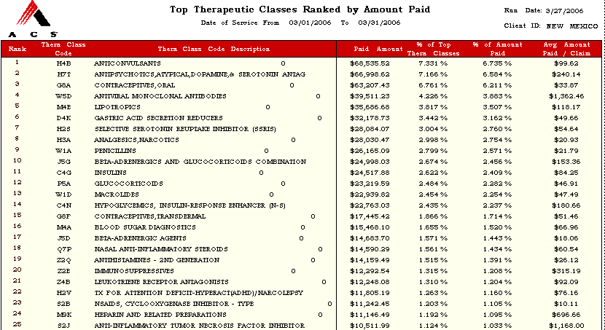

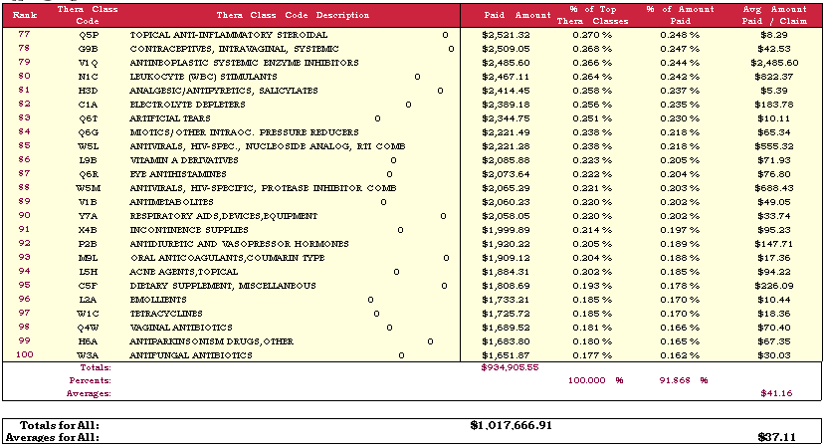

NEW MEXICO PRESCRIPTION DRUG CLAIM SYSTEM

REPORT SPECIFICATION
M1810 Top Therapeutic Classes Ranked by Number of Prescriptions

Report ID: M1810
Title: Top Therapeutic Classes Ranked by Number of Prescriptions
Frequency: Monthly
Source: OS PLUS Oracle DSS Warehouse; report generated via Business Objects
Description: This report provides a ranking of the Top Therapeutic Classes by “Number of Prescriptions”. It includes line item information for the following metrics: Rank, Therapeutic Class Code, Therapeutic Class Description, # of Claims, Amount Paid, % of Top Therapeutic Classes, % of Amount Paid, Avg Amount Paid/Claim. The summary at the bottom of the report shows Subtotals, Percents and Averages of the Top Therapeutic Classes compared to All Therapeutic Classes for each metric. The summary also shows Totals and Averages for All Therapeutic Classes for each metric. Top Therapeutic Class reports help to prioritize utilization review programs and to predict the effect of reimbursement system or benefit delivery design changes.
Metrics: Rank - Ranking of Top Therapeutic Classes Ranked by Amount Paid
Therapeutic Class Code - Therapeutic Class Code groups drugs according to their most common intended use
Therapeutic Class Description - Description of each Therapeutic Class Code
# of Claims - Unique Count of TCNs
Amount Paid - Sum of Amount Paid for each Therapeutic Class by Client
% of Top Therapeutic Classes - # of Claims for Top Therapeutic Classes divided by # of Claims for All Therapeutic Classes
% of Amount Paid - Sum of Amount Paid for Top Therapeutic Classes divided by Sum of Amount Paid for All Therapeutic Classes
Avg Amount Paid/Claim - Sum of Amount Paid divided by # of Claims
Summaries:
Amount Paid: Totals - Sum of Amount Paid for Top Therapeutic Classes
Totals For All - Sum of Amount Paid for All Therapeutic Classes
% of Top Therapeutic Classes:
Percents - Sum of Percents of % of Top Therapeutic Classes
% of Amount Paid:
Percents - Sum of Percents of % of Amount Paid
Avg Amount Paid/Claim:
Averages - Sum of Amount Paid for Top Therapeutic Classes divided by # of Claims for Top Therapeutic Classes
Averages for All - Sum of Amount Paid for All Therapeutic Classes divided by # of Claims for All Therapeutic Classes
Sort Sequence(s): Top Therapeutic Classes Ranked by Number of Prescriptions
Control Breaks: Rank Top 100
Filters: N/A
Notes: N/A

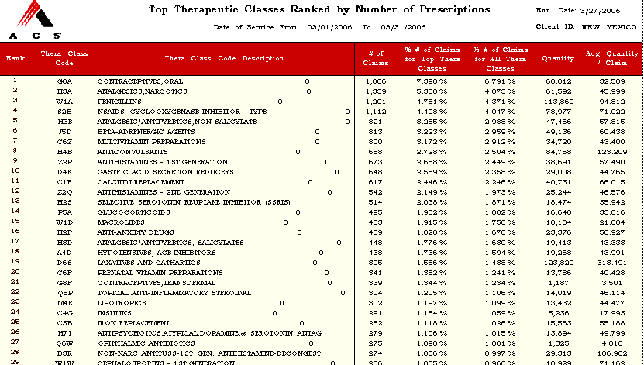

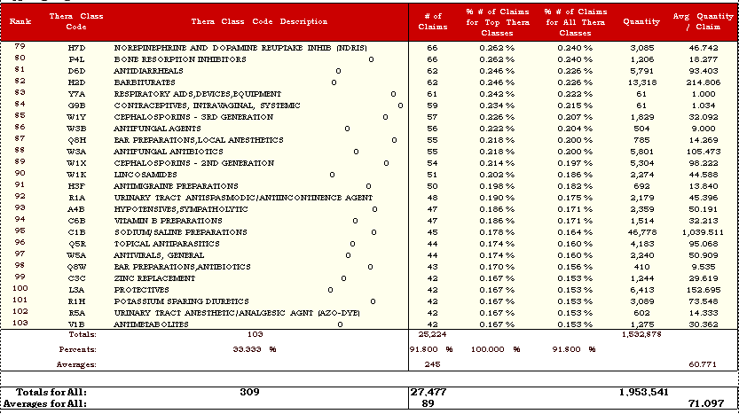

NEW MEXICO PRESCRIPTION DRUG CLAIM SYSTEM

REPORT SPECIFICATION
M1815 Therapeutic Class Summary for State Fiscal Year to Date

Report ID: M1815
Title: Therapeutic Class Summary for State Fiscal Year to Date
Frequency: Monthly
Source: OS PLUS Oracle DSS Warehouse; report generated via Business Objects
Description: This report provides information on all Therapeutic Classes for state fiscal year to date. It includes line item information for the following metrics: Drug Name, GCN, Generic Code Name, Therapeutic Class Code, Therapeutic Class Description, Brand or Generic, # of Claims, Amount Paid, Avg Amount Paid/Claim, Avg Quantity/Claim. The summary at the bottom of the report shows Totals and Averages of All Prescribed Drugs for each metric.
Metrics: Therapeutic Class Code - Specific Therapeutic Class Code groups drugs according to their most common intended use
Therapeutic Class Description - Description of each Therapeutic Class Code
# of Claims - Unique Count of TCNs
Amount Paid - Amount Paid for the Claim
Avg Amount Paid/Claim - Sum of the Amount Paid divided by the # of Claims
Avg Quantity/Claim - Sum of Quantity per Claim divided by the # of Claims
Summaries:
Therapeutic Class:
Totals For All - Unique Count of Therapeutic Classes
# of Claims: Totals For All - Sum of the # of Claims for All Therapeutic Classes
Averages For All - Sum of the # of Claims All Therapeutic Classes divided by the # of Therapeutic Classes
Amount Paid:
Totals For All - Sum of Amount Paid for All Therapeutic Classes
Averages For All - Sum of Amount Paid All Therapeutic Classes divided by the # of Therapeutic Classes
Quantity:
Totals For All - Sum of the Quantity per Claim for All Therapeutic Classes
Averages For All - Sum of the Quantity per Claim for All Therapeutic Classes divided by the # of Therapeutic Classes
Avg Amount Paid/Claim:
Averages for All - Sum of Amount Paid All Therapeutic Classes divided by Sum of the # of Claims for Therapeutic Classes Avg Quantity/Claim:
Averages for All - Sum of Quantity per Claim All Therapeutic Classes divided by Sum of the # of Claims for All Therapeutic Classes
Sort Sequence(s): N/A
Control Breaks: N/A
Filters: N/A
Notes: All Therapeutic Classes with Paid Claims in Current State Fiscal Year are Reported
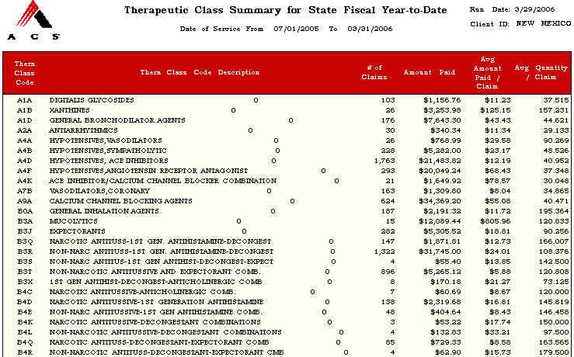
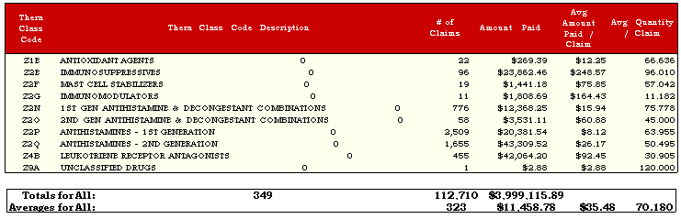
NEW MEXICO PRESCRIPTION DRUG CLAIM SYSTEM

REPORT SPECIFICATION
M1820 Therapeutic Class Utilization of Drug Names Ranked by Count of Prescriptions

Report ID: M1820
Title: Therapeutic Class Utilization of Drug Names Ranked by Count of Prescriptions
Frequency: Monthly
Source: OS PLUS Oracle DSS Warehouse; report generated via Business Objects
Description: This report provides a therapeutic class utilization of drug names ranked by count of prescriptions. It includes line item information for the following metrics: Rank by # of Claims, Rank by Amount Paid, Therapeutic Class, Therapeutic Class Description, Drug Name, GCN, # of Claims, % of Claims in Drug Class, Avg Quantity/Claim, Amount Paid, % of Claims in Drug Class, Avg Quantity/Claim. The summary at the bottom shows total, Percents , and averages for All Therapeutic Classes for each metric.
Metrics: Rank by # of Claims - Ranking of Therapeutic Class Code by Number of Claims
Rank By Amount Paid - Ranking of Therapeutic Class Code by Amount Paid
Therapeutic Class Code - Specific Therapeutic Class Code groups drugs according to their most common intended use
Therapeutic Class Description - Description of each Therapeutic Class Code
Drug Name - Drug Name & Strength
GCN - Generic Code Number
Total Number of Claims:
# of Claims - Unique Count of TCNs (TCN)
% of Claims in Drug Class - # of Claims divided by Sum of # of Claims for Each Therapeutic Class Code
Avg Quantity/Claim - Quantity divided by # of Claims
Total Amount Paid:
Amount Paid - Amount Paid for the Claim
% of Claims in Drug Class - Amount Paid divided by Sum of Amount Paid for Each Therapeutic Class Code
Avg Amount Paid/Claim - Amount Paid divided by # of Claims
Summaries:
Total Number of Claims:
# of Claims:
Totals - # of Claims for Each Therapeutic Class Code
Percents - # of Claims divided by Sum of # of Claims for Each Therapeutic Class Code
Totals For All - Sum of # of Claims for All Therapeutic Class Codes
% of Claims in Drug Class:
Percents - # of Claims divided by Sum of # of Claims for Each Therapeutic Class Code
Avg Quantity/Claim:
Averages - Quantity divided by # of Claims for Each Therapeutic Class Code
Averages for All - Quantity divided by # of Claims for All Therapeutic Class Code
Total Amount Paid:
Amount Paid:
Totals - Sum of Amount Paid for Each Therapeutic Class Code
Percents - Amount Paid divided by Sum of Amount Paid for Each Therapeutic Class Code
Totals For All - Sum of Amount Paid for All Therapeutic Class Codes
% of Claims in Drug Class:
Percents - Amount Paid divided by Sum of Amount Paid for Each Therapeutic Class Code
Avg Quantity/Claim:
Averages - Amount Paid divided by # of Claims for Each Therapeutic Class Code
Averages for All - Amount Paid divided by # of Claims for All Therapeutic Class Code

Sort Sequence(s): Therapeutic Class Utilization of Drug Names Ranked by Count of Prescriptions
Control Breaks: Therapeutic Class
Filters: N/A
Notes: N/A

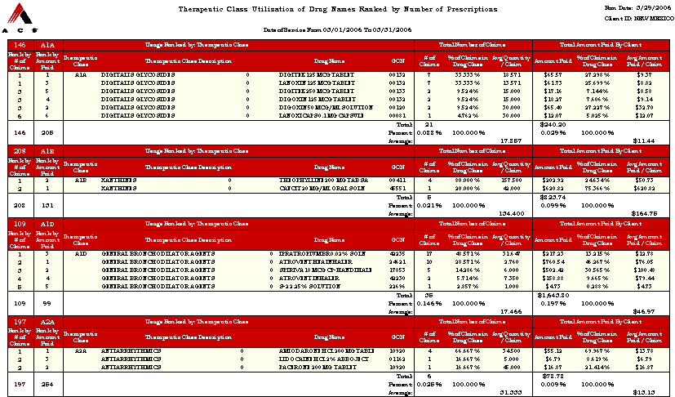

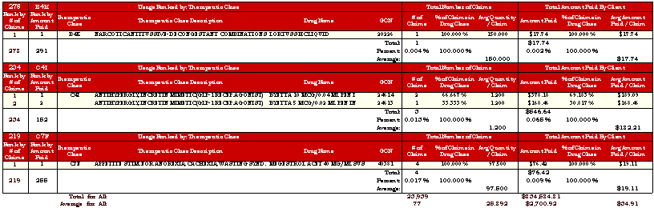
NEW MEXICO PRESCRIPTION DRUG CLAIM SYSTEM

REPORT SPECIFICATION
M1830 Therapeutic Class Utilization Ranked by Usage & Expenditure

Report ID: M1830
Title: Therapeutic Class Utilization Ranked by Usage & Expenditure
Frequency: Monthly
Source: OS PLUS Oracle DSS Warehouse; report generated via Business Objects
Description: This report provides therapeutic class utilization ranked by usage and expenditure. It includes line item information for the following metrics: # of Claims, Amount Paid, Therapeutic Class, Therapeutic Class Description, # of Claims, % of All Claims, Avg Quantity/Claim, Amount Paid, % of All Claims, Avg Amount Paid/Claim. The summary at the bottom shows Total, Percents, and Averages for All Therapeutic Classes for each metric. This report may be used to examine individual therapeutic classes to determine program effectiveness.
Metrics: Rank by # of Claims - Ranking of Therapeutic Class Code by Number of Claims
Rank By Amount Paid - Ranking of Therapeutic Class Code by Amount Paid
Therapeutic Class Code - Specific Therapeutic Class Code groups drugs according to their most common intended use
Therapeutic Class Description - Description of each Therapeutic Class Code
Total Number of Claims:
# of Claims - Unique Count of TCNs
% of All Claims- # of Claims divided by Sum of # of Claims for Each Therapeutic Class Code
Avg Quantity/Claim - Quantity divided by # of Claims
Total Amount Paid:
Amount Paid - Amount Paid for the Claim
% of Claims in Drug Class - Amount Paid divided by Sum of Amount Paid for Each Therapeutic Class Code
Avg Amount Paid/Claim - Amount Paid divided by # of Claims
Summaries:

Total Number of Claims:

Thera Class:
Totals - Count of Therapeutic Class Codes
# of Claims:
Totals - # of Claims for Each Therapeutic Class Code
Percents - # of Claims divided by Sum of # of Claims for Each Therapeutic Class Code
Totals For All - Sum of # of Claims for All Therapeutic Class Codes
% of All Claims:
Percents - # of Claims divided by Sum of # of Claims for Each Therapeutic Class Code
Avg Quantity/Claim:
Averages - Quantity divided by # of Claims for Each Therapeutic Class Code
Averages for All - Quantity divided by # of Claims for All Therapeutic Class Code

Total Amount Paid:

Amount Paid:
Totals - Sum of Amount Paid for Each Therapeutic Class Code
Percents - Amount Paid divided by Sum of Amount Paid for Each Therapeutic Class Code
Totals For All - Sum of Amount Paid for All Therapeutic Class Codes
% of Claims in Drug Class:
Percents - Amount Paid divided by Sum of Amount Paid for Each Therapeutic Class Code
Avg Quantity/Claim:
Averages - Amount Paid divided by # of Claims for Each Therapeutic Class Code
Averages for All - Amount Paid divided by # of Claims for All Therapeutic Class Code
Sort Sequence(s): Therapeutic Class Utilization Ranked by Usage & Expenditure
Control Breaks: N/A
Filters: N/A
Notes: N/A

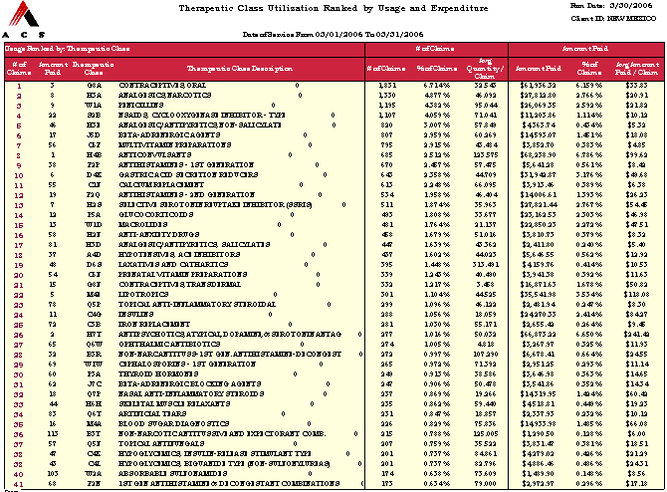

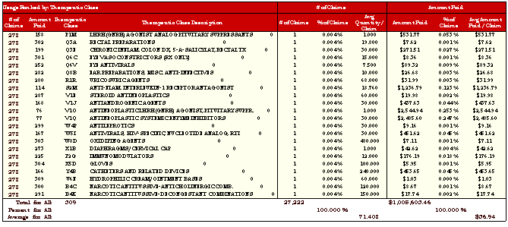

NEW MEXICO PRESCRIPTION DRUG CLAIM SYSTEM

REPORT SPECIFICATION
M1840 Therapeutic Class Utilization Ranked by Drug Usage & Expenditure

Report ID: M1840
Title: Therapeutic Class Utilization Ranked by Drug Usage & Expenditure
Frequency: Monthly
Source: OS PLUS Oracle DSS Warehouse; report generated via Business Objects
Description: This report provides therapeutic class utilization ranked by drug usage and expenditure. It includes line item information for the following metrics: # of Claims, Amount Paid, Drug Name, GCN, Therapeutic Class, Therapeutic Class Description, # of Claims, % of All Claims, Avg Quantity/Claim, Amount Paid, % of All Claims, Avg Amount Paid/Claim. The summary at the bottom shows Total, Percents, and Averages for All Therapeutic Classes for each metric. This report may be used to examine individual drugs to determine program effectiveness.
Metrics: Rank by # of Claims - Ranking of Therapeutic Class Code by Number of Claims
Rank By Amount Paid - Ranking of Therapeutic Class Code by Amount Paid
Drug Name - Drug Name & Strength
GCN - Generic Code Number
Therapeutic Class Code - Specific Therapeutic Class Code groups drugs according to their most common intended use
Therapeutic Class Description - Description of each Therapeutic Class Code
Total Number of Claims:
# of Claims - Unique Count of TCNs
% of All Claims - # of Claims divided by Sum of # of Claims for Each Therapeutic Class Code
Avg Quantity/Claim - Quantity divided by # of Claims
Total Amount Paid:
Amount Paid - Amount Paid for the Claim
% of All Claims - Amount Paid divided by Sum of Amount Paid for Each Therapeutic Class Code
Avg Amount Paid/Claim - Amount Paid divided by # of Claims
Summaries:

Total Number of Claims:

# of Claims:
Totals - # of Claims for Each Therapeutic Class Code
Percents - # of Claims divided by Sum of # of Claims for Each Therapeutic Class Code
Totals For All - Sum of # of Claims for All Therapeutic Class Codes
% of Claims in Drug Class:
Percents - # of Claims divided by Sum of # of Claims for Each Therapeutic Class Code
Avg Quantity/Claim:
Averages - Quantity divided by # of Claims for Each Therapeutic Class Code
Averages for All - Quantity divided by # of Claims for All Therapeutic Class Code

Total Amount Paid:

Amount Paid:
Totals - Sum of Amount Paid for Each Therapeutic Class Code
Percents - Amount Paid divided by Sum of Amount Paid for Each Therapeutic Class Code
Totals For All - Sum of Amount Paid for All Therapeutic Class Codes
% of Claims in Drug Class:
Percents - Amount Paid divided by Sum of Amount Paid for Each Therapeutic Class Code
Avg Quantity/Claim:
Averages - Amount Paid divided by # of Claims for Each Therapeutic Class Code
Averages for All - Amount Paid divided by # of Claims for All Therapeutic Class Code
Sort Sequence(s): By Therapeutic Class
Control Breaks: N/A
Filters: N/A
Notes: N/A

